**SOFTWARE ENGINEERING**

**IT350**

**DESIGN DIAGRAMS**

**SUBMITTED BY:**

RAJGAURI KHEMNAR

15IT133

**SUBMITTED TO:**

RAKSHA NADGIR

**DATE:**

27.02.2018

1. USE CASE DIAGRAM:

Macintosh HD:Users:rajgaurikhemnar:programs:software_engineering:Use Case Diagram for Online Shopping System (UML).pdf

2. ENTITY-RELATIONSHIP DIAGRAM:

Macintosh HD:Users:rajgaurikhemnar:programs:software_engineering:er diagram.pdf

3.a. NAVIGATION DIAGRAM- CUSTOMER:

Macintosh HD:Users:rajgaurikhemnar:programs:software_engineering:navigation-customer.pdf

3.b NAVIGATION DIAGRAM-ADMIN:Macintosh HD:Users:rajgaurikhemnar:programs:software_engineering:navigation -admin.pdf

4. SWIMLANE DIAGRAM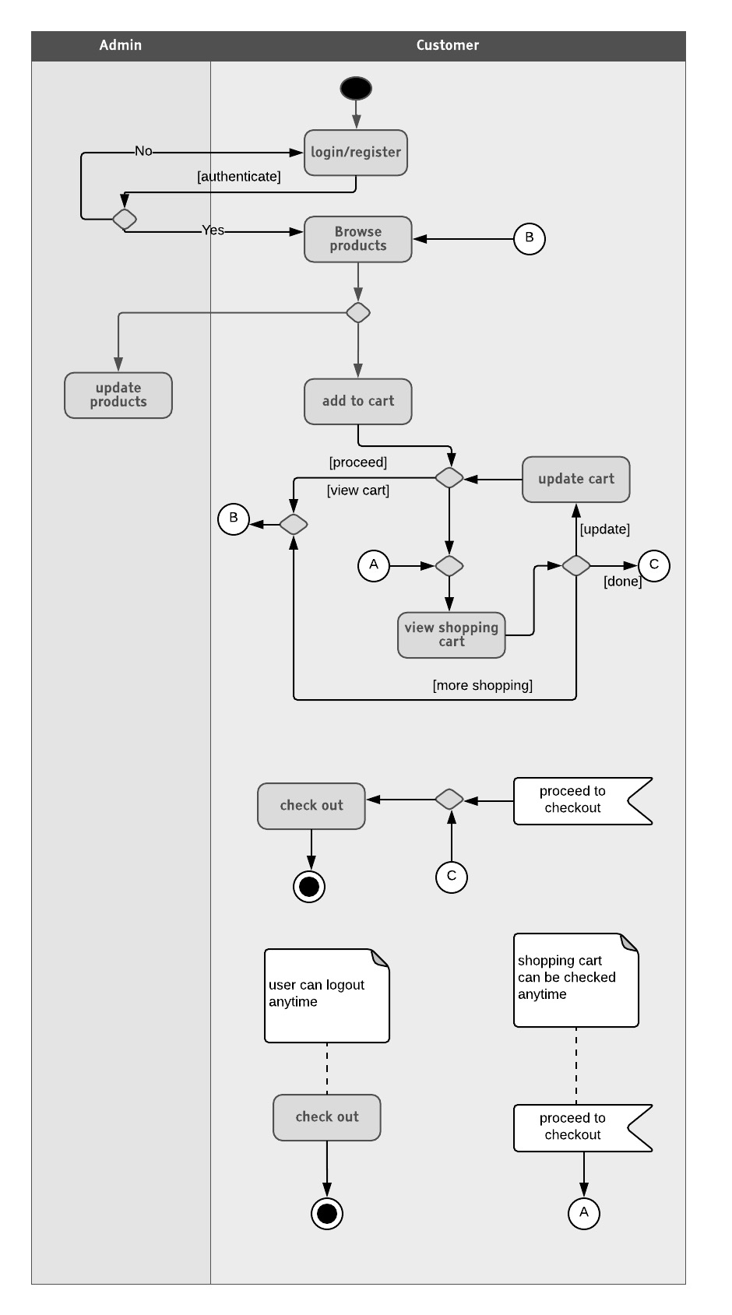

5. SEQUENCE DIAGRAM:

Macintosh HD:Users:rajgaurikhemnar:programs:software_engineering:sequence diagram.pdf

6. ACTIVITY DIAGRAM:

Macintosh HD:Users:rajgaurikhemnar:programs:software_engineering:Activity Diagram.pdf